**A** **PROJECT REPORT**

**ON**

**“THE EMPORIUM”** **FOR**

**“INTELLORE SYSTEMS PVT LTD”**

**SUBMITTED BY**

**Mr. Dhananjay Manik Bhagat**

**D. Y. PATIL INSTITUTE OF MCA AND MANAGEMENT AKURDI, PUNE -411044**

**ACADEMIC YEAR 2023-2024**

**A** **PROJECT REPORT**

**ON**

**“THE EMPORIUM”** **FOR**

**“INTELLORE SYSTEMS PVT LTD”** **SUBMITTED BY**

**Mr. Dhananjay Manik Bhagat**

**IN PARTIAL FULFILMENT OF**

**MASTER OF COMPUTER APPLICATION (MCA)**

**SAVITRIBAI PHULE PUNE UNIVERSITY**

**D. Y. PATIL INSTITUTE OF MCA AND MANAGEMENT AKURDI, PUNE -411044**

**ACADEMIC YEAR 2023-2024**



 Dr. D. Y. Patil Pratishthan’s

**D.Y. Patil Institute of Master of Computer Applications**

**And Management**

Sector No.29, Behind Akurdi Railway Station, Pradhikaran, Nigdi, Pune – 411044

Tel No: 020-27640998, 202737393, Fax no: 27653054, Website: www.dypimca.ac.in,

Email: director@dypimca.ac.in

**(Approved by AICTE, Recognized by DTE, Mah.; Affiliated to SPPU)**

**Ref:** DYPIMCAM/Acad/Note/ 100/23 Date: 17/05/2024

**CERTIFICATE**

This is to certify that the Project entitled

**“THE EMPORIUM”**

Has been successfully completed

By

**Mr. Dhananjay Manik Bhagat**

Towards the partial fulfillment of

M.C.A. (Master of Computer Application)

Under

Savitribai Phule PuneUniversity for

Academic Year 2023-2024

**Ms. Yogeshwari Yawalkar**

**Project Guide Internal Examiner**

**Dr. Kavita Suryawanshi Dr. K Nirmala**

**HOD-MCA, Vice Principal Director**

**External Examiner**

# Acknowledgement

I would take the opportunity to thank **Dr. K. Nirmala, Director, DYPIMCA and Management** for her support, extended to me throughout the course.

I would like to thank **Dr. Kavita Suryawanshi, Vice Principal,** for her scholarly disposition, timely guidance, support and cooperation.

I would like to thank **Ms.Yogeshwari Yawalkar** for her kind guidance, keen interest, continuous encouragement and inspiration throughout the project work.

Finally, I gratefully thank all the faculty members of DYPIMCA and Management for their cooperation and support.

I also thankful to get constant encouragement, support and guidance from all Teaching and Non- Teaching Staff for their timely support which helped us in successfully completion of our project work.

Dhananjay Manik Bhagat

MCA II

Div : C

Roll No :142

Seat No : 4272

**Dr. D. Y. Patil Pratishthan’s**

**D. Y. Patil Institute of Master of Computer Applications and Management**

**(M.C.A. Programme)**

(Approved by AICTE, New Delhi & Affiliated to Savitribai Phule Pune University)

**Dr. D. Y. Patil Educational Complex, Sector 29, Pradhikaran, Akurdi, Pune – 411 044**Tel No: (020)27640998, Website: www.dypimca.ac.in, E-mail : [director@dypimca.ac](mailto:director@dypimca.ac).

|  |  |  |
| --- | --- | --- |
| **INDEX** | | |
| **Sr. No.** | **Details** | **Page No** |
| **1** | **Chapter 1: Introduction** | 3 |
| 1.1 | Client Profile | 4 |
| 1.2 | Abstract | 5 |
| 1.3 | Existing System and Need for System | 6 |
| 1.4 | Scope of System | 7 |
| 1.5 | Operating Environment - Hardware and Software | 8 |
| 1.6 | Brief Description of Technology Used | 9 – 10 |
| **2** | **Chapter 2: Proposed System** | 11 |
| 2.1 | Study of Similar Systems (If required research paper can be included) | 12 |
| 2.2 | Feasibility Study | 14 |
| 2.3 | Objectives of Proposed System | 18 |
| 2.4 | Users of System | 19 |
| **3** | **Chapter 3: Analysis and Design** | 20 |
| 3.1 | System Requirements (Functional and Non-Functional requirements) | 21 |
| 3.2 | Module Specification | 22 |
| 3.3 | Entity Relationship Diagram (ERD) | 23 |
| 3.4 | Table Structure | 24 – 26 |
| 3.5 | Use Case Diagrams | 27 |
| 3.6 | Class Diagram | 28 |
| 3.7 | Activity Diagram | 29 |
| 3.8 | Deployment Diagram | 31 |
| 3.9 | Module Hierarchy Diagram | 32 |
| 3.10 | Sample Input and Output Screens (Screens must have valid data. All reports must have at-least 5 valid records.) | 33 - 39 |
| **4** | **Chapter 4: Coding** | 40 |
| 4.1 | Code snippets | 41 - 45 |
| **5** | **Chapter 5: Testing** | 46 |
| 5.1 | Test Strategy | 47 |
| 5.2 | Unit Test Plan | 48 |
| 5.3 | Acceptance Test Plan | 48 |
| 5.4 | Test Case | 49 – 52 |
| **6** | **Limitations of Proposed System** | 53 |
| **7** | **Proposed Enhancements** | 56 |
| **8** | **Conclusion** | 58 |
| **9** | **Bibliography** | 60 |
| **10** | **User Manual** ( All GUI screens with validation description etc.) | 62 |
| 10.1 | Annexure 1: User Interface Screens | 63 |
| 10.2 | Annexure 2: Output Reports with Data | 66 |
| 10.3 | Annexure 3: Sample Program Code | 67 |

**Chapter No. 1**

**INTRODUCTION**

## INTRODUCTION :

In today's dynamic market landscape, efficient management of dairy products and seamless online shopping experiences are paramount for businesses seeking to thrive. The Dairy Product Management System, a Python-based solution, emerges as a comprehensive tool tailored for managing and tracking diverse dairy products within farm or processing facilities. By streamlining inventory management, sales tracking, and customer interactions, this system offers a robust framework to enhance operational efficiency and meet evolving cons4umer demands. Complementing this,

The Emporium website stands as a beacon of innovation, poised to revolutionize the online shopping experience for fashion enthusiasts. With a unified platform hosting multiple vendors and an array of products, The Emporium promises to broaden business reach and amplify customer engagement, heralding a new era of convenience and accessibility in e- commerce.

report encapsulates a detailed overview of both projects, shedding light on their objectives, features, implementation intricacies, and future prospects. The Dairy Product Management System emerges as a testament to the transformative potential of technology in optimizing dairy operations, offering a tailored solution to address industry-specific challenges. Similarly,

The Emporium website underscores the power of digital platforms in reshaping traditional retail paradigms, offering a cohesive ecosystem for vendors and consumers alike to connect and transact seamlessly. By emphasizing the significance of information security and the imperative of accurate cost estimation, this report sets the stage for a meticulous exploration of these projects' intricacies and their pivotal role in driving business innovation and growth in an increasingly digitized world.

In an era marked by unprecedented technological advancement and shifting consumer behaviors, the Dairy Product Management System and The Emporium website represent innovative solutions poised to redefine their respective industries. With a focus on enhancing operational efficiency, improving customer experiences, and fostering business growth, these projects embody a commitment to harnessing the power of technology to meet the evolving needs of modern businesses and consumers. By facilitating seamless management of dairy products and offering a diverse online shopping platform, these initiatives pave the way for increased productivity, profitability, and competitiveness in an ever-evolving market landscape.

As businesses embrace digital transformation as a cornerstone of their strategies, the Dairy Product Management System and The Emporium emerge as beacons of innovation, driving progress and shaping the future of their respective industries with their forward- thinking approach and unwavering dedication to excellence.

## COMPANY PROFILE

**About Us:**

Intellore is a leading provider of co-creation technology services, specializing in accelerating the digital transformation journey for businesses across various industries. Our innovative solutions range from edge devices to cloud platforms and enterprise applications, aimed at creating new value for all stakeholders. With a commitment to excellence and a focus on collaborative partnerships, we empower organizations to excel in today's digital landscape.

**Our Services:**

At Intellore, we offer a comprehensive suite of digital transformation services tailored to meet the evolving needs of our clients. From domain-specific Embedded Systems powering Intelligent Edge Devices to differentiated Cloud Applications, we provide end-to-end solutions to catalyze your digital journey. Our expertise extends to software design and development, enabling businesses to leverage the latest technologies for competitive advantage.

**Verticals We Serve**:

Intellore caters to a diverse range of industries, harnessing the power of digitalization to drive innovation and growth. Our intelligence-driven solutions span across:

- **Intelligent Energy**: Revolutionizing conventional and renewable energy value chains.

**- Intelligent Healthcare**: Leveraging new technologies in wearables and cloud-based apps.

**- Intelligent Buildings**: Pioneering sustainable, green building solutions.

**- Intelligent Transportation**: Navigating the complexities of connected vehicle technologies.

- **Intelligent Manufacturing**: Unlocking the potential of Industry 4.0 and IIOT.

- **Intelligent Work-Sites**: Transforming worksites with customized digital solutions.

- **Intelligent Cities**: Driving digital transformation in urban ecosystems.

- **Intelligent Digital Platforms**: Empowering partner ecosystems with cutting-edge digital platforms.

**Client Testimonials:**

Trusted globally by leading organizations, Intellore has garnered praise for our exceptional capabilities and collaborative approach. Our clients attest to the seamless execution and tangible results delivered by our dedicated team.

* 1. **ABSTRACT**

In an era defined by technological innovation and shifting consumer preferences, the Dairy Product Management System and The Emporium website emerge as transformative projects poised to reshape the dairy management and e-commerce sectors, respectively.

The Dairy Product Management System, leveraging the versatility of Python, is meticulously crafted to streamline the intricate processes involved in managing and tracking dairy products within farms and processing facilities.

By offering robust features for inventory management, sales tracking, and customer engagement, this system promises to enhance operational efficiency and facilitate informed decision-making. Simultaneously, The Emporium website heralds a new frontier in online shopping by providing a unified platform for fashion vendors to showcase their products. Through a user- friendly interface and comprehensive product management capabilities, The Emporium aims to revolutionize the e-commerce landscape, offering customers unparalleled convenience and choice.

Central to the success of both projects is a steadfast commitment to information security and accurate cost estimation. Recognizing the critical importance of safeguarding sensitive data, the Dairy Product Management System incorporates robust security measures to protect against potential threats and vulnerabilities.

Similarly, The Emporium prioritizes the confidentiality and integrity of customer information, ensuring a safe and secure shopping environment for all users. Moreover, both projects emphasize the need for meticulous cost estimation to ensure the efficient allocation of resources and mitigate project risks. By conducting thorough probabilistic assessments, project stakeholders can gain valuable insights into the anticipated costs and effort required, enabling them to make informed decisions and optimize project outcomes.

* 1. **EXISTING SYSTEM AND NEED FOR SYSTEM**

# Needs of System :

In the modern dairy industry, there exists a pressing need for streamlined processes and efficient management systems to address several critical challenges. Firstly, manual processes are pervasive in many dairy operations, leading to errors, inefficiencies, and difficulties in data retrieval and analysis.

This reliance on manual methods significantly hampers productivity and accuracy in managing dairy product inventory, sales, and customer records. Secondly, the lack of real-time information poses a significant hurdle, as without automated systems, obtaining up-to-date data on stock levels, sales performance, and customer preferences becomes arduous.

Timely access to this information is essential for informed decision- making and proactive action in response to market dynamics. Additionally, limited reporting capabilities hinder the ability to generate comprehensive reports on product performance, sales trends, and other vital metrics, inhibiting strategic planning and optimization efforts.

# Existing Systems:

The prevailing systems in many dairy farms or processing facilities are characterized by manual processes and a lack of automation, leading to several operational inefficiencies. Manual inventory management practices often result in inaccuracies and time-consuming tasks, such as tracking expiration dates and maintaining stock records.

Furthermore, the absence of integration with other systems or software exacerbates these challenges, fostering data silos, duplicated efforts, and inconsistencies in data management. Customer management processes, too, are typically manual, relying on paper-based records or spreadsheets, which can impede effective customer tracking and engagement. Overall, the existing systems fail to provide the necessary tools and capabilities to address the complexities of modern dairy operations, highlighting the urgent need for comprehensive and integrated management solutions.

## SCOPE OF SYSTEM

The proposed online shopping system aims to provide a comprehensive platform that seamlessly manages the entire shopping experience for users while addressing key challenges faced by traditional brick-and-mortar stores and existing e-commerce platforms. With a focus on ease of use and accessibility, the system's scope encompasses various facets of online shopping, including product browsing, selection, payment, and post-purchase support.

First and foremost, the system enables users to manage their online shopping activities easily, offering intuitive navigation and streamlined processes for browsing through products, adding items to cart, and completing transactions. A robust registration and profile management system ensures secure access for customers, safeguarding their personal information and preferences.

Furthermore, the system emphasizes quick and effortless access to specific products and services, allowing users to find what they need with minimal effort. Its user-friendly interface and intuitive design make it easy to navigate, ensuring a seamless shopping experience for users of all backgrounds and technological proficiency levels.

One of the key features of the system is its ability to provide instant access to detailed product information, allowing users to make informed purchasing decisions without the need to visit physical stores or external websites. Moreover, the system ensures accuracy in cost estimation and product descriptions, enhancing user trust and confidence in the platform.

Additionally, the system offers a wide range of products across different categories and brands, providing users with a comprehensive selection to choose from. With instant bill calculation and online payment capabilities, users can complete transactions swiftly and securely, saving time, effort, and costs associated with traditional shopping methods.

Overall, the scope of the system encompasses a holistic approach to online shopping, offering convenience, security, and efficiency to users while addressing their diverse needs and preferences in the digital marketplace.

## OPERATING ENVIRONMENT – HARDWARE AND SOFTWARE

* + - **HARDWARE REQUIREMENTS :**
      * Processor: Intel i3 10th Generation & above.
      * Hard Disk: 25 GB Minimum.
      * RAM: 1 GB Minimum.

## SOFTWARE REQUIREMENTS :

* + - * Operating System: Windows 7 and Higher Version.
      * Front – End: HTML, CSS, Bootstrap, JavaScript
      * Back - End: Python Django
      * Database: SQLite
      * Editor: PyCharm
      * Browser : Google Chrome, Microsoft Edge or Any Browser

## BRIEF DESCRIPTION OF TECHNOLOGY USED

1. **HTML**

HTML (HyperText Markup Language) is the standard markup language used to create and structure web pages. It consists of elements represented by tags, defining the structure and content of a webpage. HTML documents are interpreted by web browsers to display text, images, multimedia, and interactive elements. With its simplicity and versatility, HTML forms the foundation of the World Wide Web.

## CSS

CSS (Cascading Style Sheets) is a style sheet language used to describe the presentation of a document written in HTML or XML. It allows web developers to control the layout, appearance, and design of web pages, including aspects such as fonts, colors, spacing, and positioning. CSS enhances the visual appeal and usability of websites by separating the content from its presentation, thereby enabling efficient maintenance and consistent styling across multiple pages.

## Bootstrap

Bootstrap is a popular front-end framework for building responsive and mobile-first websites and web applications. It provides a collection of pre-built HTML, CSS, and JavaScript components, such as navigation bars, buttons, forms, and grids, that streamline the development process and ensure consistency across different devices and screen sizes. With its extensive library of customizable components and responsive design utilities, Bootstrap empowers developers to create sleek and professional-looking interfaces with minimal effort.

## JavaScript

JavaScript (JS) is a versatile programming language commonly used in web development to add interactivity and dynamic behavior to websites. It runs on the client side within web browsers, allowing developers to manipulate webpage elements, respond to user actions, and update content dynamically.

JavaScript is essential for creating interactive features such as dropdown menus,

sliders, form validation, and animations. It also enables communication with servers, handling asynchronous tasks, and building complex web applications.

## Django

Django is a high-level web framework written in Python, designed to facilitate rapid development and clean, pragmatic design. It follows the "Don't Repeat Yourself" (DRY) principle and emphasizes the reusability of components, making it ideal for building complex, data-driven web applications.

Django provides a comprehensive set of features, including an Object- Relational Mapping (ORM) system for interacting with databases, a powerful templating engine for generating dynamic HTML content, and built-in security features to protect against common web vulnerabilities. Additionally, Django includes a robust administrative interface, authentication mechanisms, and support for internationalization and localization, enabling developers to focus on building functionality rather than boilerplate code.

## SQLite

SQLite is a lightweight, embedded relational database management system (RDBMS) that is self-contained, serverless, and requires minimal configuration. It is widely used in applications where a full-fledged relational database system such as MySQL or PostgreSQL may be overkill. SQLite stores data in a single file, making it easy to deploy and manage.

Despite its small footprint, SQLite supports most of the SQL standard and provides features such as transactions, indexes, triggers, and views. It is particularly popular in mobile app development, web browsers, embedded systems, and other scenarios where simplicity, reliability, and performance are paramount.

**Chapter No. 2**

**PROPOSED SYSTEM**

## PROPOSED SYSTEM

The proposed system in the project "THE EMPORIUM" is focused on enhancing the user experience and operational efficiency within a dairy farm or processing facility. It aims to provide a user-friendly interface with robust database security measures to ensure data integrity and confidentiality. By allowing only authorized users access to various functions and processes, the system ensures controlled and secure operations.

Efficient management of dairy product inventory is a key objective of the proposed system. This includes tracking stock levels, monitoring expiration dates, and maintaining detailed product information. Streamlining sales and billing processes is another crucial aspect, with features for generating invoices and managing customer records seamlessly integrated into the system.

Real-time insights into product availability, sales performance, and customer preferences will be provided to facilitate informed decision-making and strategic planning. Administrative tasks such as updating product information and generating reports will be simplified, saving time and improving overall productivity.

By enhancing speed and reducing time consumption, the system aims to optimize operational processes and increase profitability for the dairy farm or processing facility. The proposed system is designed to be a comprehensive solution that addresses the specific needs and challenges faced in managing dairy products effectively and efficiently.

## PROBLEM STATEMENT

The problem statement addressed in the project "THE EMPORIUM" revolves around the inefficiencies and challenges posed by manual processes in managing dairy product inventory, sales, and customer records within a dairy farm or processing facility.

The reliance on manual methods leads to errors, inefficiencies, and difficulties in data retrieval and analysis. Without an automated system, obtaining real-time information about stock levels, sales performance, and customer preferences becomes arduous, hindering decision-making and timely actions.

The lack of robust reporting and analytics features in the current system further exacerbates the challenges, making it difficult to generate detailed reports on product performance, sales trends, and other essential metrics.

Moreover, manual tracking of dairy product inventory is error-prone and time-consuming, making it challenging to monitor expiration dates, identify low stock levels, and maintain accurate records.

The existing system's lack of integration with other systems or software used within the dairy farm results in data silos and duplication of efforts.

Customer management relying on manual processes, such as paper-based records or spreadsheets, poses additional challenges in effectively tracking customer information.

Therefore, the project aims to address these limitations by developing an automated system that streamlines operations, improves data accuracy, enhances decision-making capabilities, and ultimately increases productivity and profitability in dairy product management.

## FEASIBILITY STUDY

The feasibility study for the project "THE EMPORIUM" involves assessing the technical, economic, and operational aspects to determine the viability and potential success of the proposed system.

The feasibility study for "THE EMPORIUM" project involves assessing technical requirements, economic viability, and operational practicality. This includes evaluating if the proposed system can be developed using available technology, determining the cost-effectiveness of implementation, and assessing how well the system will meet operational needs.

By analyzing these aspects, the feasibility study helps in determining the potential success and viability of the project within the dairy farm or processing facility.

* + 1. Technical Feasibility:
    2. Economic Feasibility:
    3. Operational Feasibility:

By conducting a comprehensive feasibility study encompassing technical, economic, and operational aspects, the project team can evaluate the viability of implementing the proposed system and make informed decisions regarding its development and deployment within the dairy farm or processing facility.

## TECHNICAL FEASIBILITY

1. Technical Feasibility

## “Technical feasibility is carried out to determine weather the company has the capability in terms of software, hardware, personnel and expertise, to handle the completion of the project”.

The technical feasibility study for "THE EMPORIUM" project involves evaluating whether the proposed system can be developed using the available technology and resources.

This assessment includes determining if the hardware and software requirements, such as processors, RAM, operating systems, and programming languages, are feasible within the existing infrastructure of the dairy farm or processing facility.

By analyzing technical aspects, such as compatibility, scalability, and implementation complexity, the technical feasibility study aims to ensure that the system can be effectively developed and integrated into the organization's operations.

## ECONOMIC FEASIBILITY

1. Economic Feasibility:

## "Economic feasibility" entails evaluating whether a project can generate sufficient returns to justify its costs, considering factors like market demand, financial viability, and risk assessment. It determines if the endeavor is economically viable and likely to yield positive outcomes.

The economic feasibility study focuses on assessing the cost-effectiveness of implementing the "THE EMPORIUM" system. This evaluation includes estimating the initial development costs, ongoing maintenance expenses, and potential return on investment.

By analyzing the financial implications of the project, including cost estimation, budget allocation, and revenue projections, the economic feasibility study aims to determine the financial viability of the system.

This assessment helps in making informed decisions regarding resource allocation and budget planning for the successful implementation and sustainability of the project.

## OPERATIONAL FEASIBILITY

1. Operational Feasibility:

## "Operational feasibility" assesses whether a proposed project or system can be implemented effectively within an organization's existing structure, processes, and resources. It considers factors such as technical compatibility, ease of integration, user acceptance, and the availability of necessary skills and resources.

The operational feasibility study for "THE EMPORIUM" project involves assessing whether the proposed system will meet the operational requirements and objectives of the dairy farm or processing facility.

This evaluation includes analyzing how the system will impact daily operations, user acceptance, and organizational processes.

Factors such as user training, system integration, and potential disruptions are considered to determine the practicality and usability of the system within the operational environment.

By evaluating these aspects, the operational feasibility study helps in ensuring that the system aligns with the organization's needs and can be effectively implemented to enhance operational efficiency and productivity.

## OBJECTIVE OF PROPOSED SYSTEM

1. **Provide a user-friendly interface**- for ease of use and enhanced security for database access, ensuring a seamless experience for users while maintaining data integrity and confidentiality.
2. **Enable authorized users-** to access various functions and processes within the system, empowering them to efficiently perform their tasks and responsibilities with secure access controls.
3. **Efficiently manage dairy product inventory**-, including tracking stock levels, expiration dates, and product details, to optimize inventory control and prevent wastage through accurate monitoring.
4. **Facilitate smooth sales and billing** processes, including generating invoices and maintaining customer records, to streamline transactions and enhance customer satisfaction with efficient billing procedures.
5. **Provide real-time insights** into product availability, sales performance, and customer preferences, enabling data-driven decision-making and personalized customer experiences based on up-to-date information.
6. **Streamline administrative tasks**, such as adding or updating product information and generating reports, to simplify operational processes and improve overall efficiency in managing dairy product information.
7. **Enhance overall productivity and** profitability of the dairy farm or processing facility by implementing a comprehensive system that increases operational efficiency and drives business growth through optimized processes.
8. **Improve speed and reduce time consumption** for accessing information within the system, ensuring quick and easy retrieval of data for enhanced productivity and decision-making capabilities.

## MODULES OF PROPOSED SYSTEM

1. **Admin Login Module:**
   * Allows administrators to securely log in to the system with username and password credentials.

## Product Module:

* + Manages product details related to purchase and sales, including product information and inventory tracking.

## Customer Module:

* + Stores and organizes customer details, including purchases, contact information, and preferences.

## Seller Module:

* + Manages information about vendors from whom products are purchased, including contact details and product sources.

## Search Module:

* + Enables users to search for specific products or information within the system for quick access.

## Purchase Details Module:

* + Handles purchase transactions, tracking the products purchased from vendors for inventory management.

## Sales Details Module:

* + Manages sales transactions, tracking products sold to customers and generating invoices for billing.

## Report Generation Module:

- Provides functionality for generating reports on sales, inventory, and other relevant data for analysis and decision-making.

## Chatbot:

-Integrated a user friendly chatbot to help with the website and to navigate easily between website.

**Chapter No. 3**

**ANALYSIS & DESIGN**

## SYSTEM REQUIREMENTS

This Section provides requirements overview of the system. Various functional modules that can be implemented by the system will be :

## FUNCTIONAL REQUIREMENTS

* + 1. Registration -

If customer wants to order the product/item then he/she must be register. Unregister customer cannot buy the product.

* + 1. Login -

Customer logins to the system by entering valid user id and password for order the products online.

* + 1. Changes to Cart -

Changes to cart means the customer after login or registration can make order or cancel order of the item from the cart.

1. Logout -

After the payment or searching, the product the customer will logged out.

1. Report Generation -

After all transaction, the system can generate the portable document file (.pdf) and then sent one copy to the system database to calculate the monthly transaction.

## NON – FUNCTIONAL REQUIREMENTS

1. Security-

The system use SSL (secured socket layer) in all transactions that include any confidential customer information. The system must automatically log out all customers after a period of inactivity.

The system should not leave any cookies on the customer's computer containing the user's password. The system's back-end servers shall only be accessible to authenticated administrators. Sensitive data will be encrypted before sent over insecure connections like the internet.

1. Reliability -

The system provides storage of all databases on redundant computers with automatic switch over. The reliability of the overall program depends on the reliability of the separate components.

The system has a backup of the database, which is continuously maintained and updated to reflect the most recent changes.Thus, the overall stability of the system depends on the stability of container and its underlying operating system.

1. Availability -

The system should be available at all times, meaning the user can access it using a web browser, only restricted by the down time of the server on which the system runs. In case of a hardware failure or database corruption, a replacement page will show.

Also, in case of a hardware failure or database corruption, backups of the database should be retrieved from the server and saved by the administrator. Then the service will be restarted. It means 24 X 7 availability.

1. Maintainability -

A commercial database used for maintaining the database and the application server takes care of the site. In case of failure, a reinitialization of the program will be done. In addition, a software design done with modularity in mind so that maintainability done efficiently.

## ENTITY RELATIONSHIP DIAGRAM ( ERD)

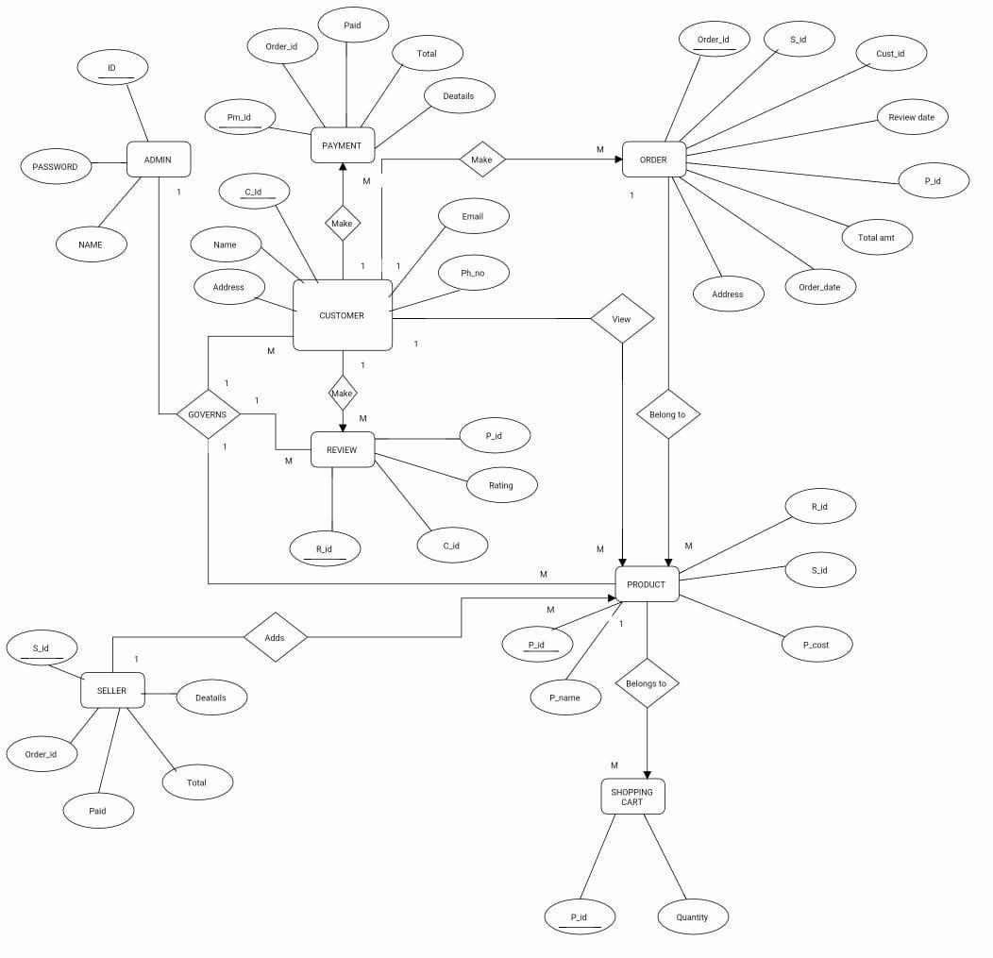

* 1. **TABLE STRUCTURE**
* **Admin Table**

|  |  |  |  |  |  |
| --- | --- | --- | --- | --- | --- |
| Sr.No | Field Name | Data Type | Size | Constraints | Description |
| 1 | Id | Integer | 100 | Primary Key | Admin Id |
| 2 | Uname | Varchar | 100 | Not Null | Admin Name |
| 3 | Password | Varchar | 100 | Not Null | Admin Password |

* **Product Detail Table**

|  |  |  |  |  |  |
| --- | --- | --- | --- | --- | --- |
| Sr.No | Field Name | Data Type | Size | Constraints | Description |
| 1 | Prod_id | Varchar | 100 | Primary key | Product Id |
| 2 | Prod_name | Varchar | 45 | Not Null | Product Name |
| 3 | Prod_qty | Integer | 45 | Not Null | Product Quantity |
| 4 | Prod_price | Integer | 45 | Not Null | Product Price |
| 5 | Prod_desc | Varchar | 200 | Not Null | Product Description |
| 6 | Seller_id | Varchar | 100 | Foreign Key | Seller Id |

* + **Customer Table**

|  |  |  |  |  |  |
| --- | --- | --- | --- | --- | --- |
| Sr.No | Field Name | Data Type | Size | Constraints | Description |
| 1 | C_id | Varchar | 100 | Primary Key | Customer id |
| 2 | C_name | Varchar | 45 | Not Null | Customer Name |
| 3 | C_contact | Varchar | 45 | Not Null | Customer Contact |
| 4 | C_email | Varchar | 45 | Not Null | Customer Email id |
| 5 | C_address | Varchar | 45 | Not Null | Customer Address |
| 6 | C_Gender | Varchar | 45 | Not Null | Customer Gender |

* **Seller Table**

|  |  |  |  |  |  |
| --- | --- | --- | --- | --- | --- |
| Sr.No | Field Name | Data Type | Size | Constraints | Description |
| 1 | Seller_id | Varchar | 100 | Primary Key | Seller id |
| 2 | Seller_name | Varchar | 45 | Not Null | Seller Name |
| 3 | Contact | Varchar | 45 | Not Null | Seller Contact |
| 4 | Email | Varchar | 45 | Not Null | Seller Email id |
| 5 | Address | Varchar | 45 | Not Null | Seller Address |

* **Payment Table**

|  |  |  |  |  |  |
| --- | --- | --- | --- | --- | --- |
| Sr.No | Field Name | Data Type | Size | Constraints | Description |
| 1 | Payment_id | Varchar | 100 | Primary Key | Purchase id |
| 2 | Order_id | Varchar | 100 | Foreign Key | Seller id |
| 3 | Prod_id | Varchar | 100 | Foreign Key | Product id |
| 4 | Order_qty | Integer | 45 | Not Null | Order Quantity |
| 5 | Prod_price | Integer | 45 | Foreign Key | Product Price |

* **Order Table**

|  |  |  |  |  |  |
| --- | --- | --- | --- | --- | --- |
| Sr.No | Field Name | Data Type | Size | Constraints | Description |
| 1 | Order_id | Varchar | 100 | Primary Key | Order id |
| 2 | C_id | Varchar | 100 | Foreign Key | Customer id |
| 3 | Prod_id | Varchar | 100 | Foreign Key | Product id |
| 4 | Prod_name | Varchar | 45 | Not Null | Product Name |
| 5 | Quantity | Integer | 45 | Not Null | Quantity |
| 6 | Prod_price | Integer | 100 | Not Null | Product Price |
| 7 | Total_amt | Integer | 100 | Not Null | Total Amount |
| 8 | Order date | Timestamp | 20 | Not Null | Current Timestamp |

## Review table

|  |  |  |  |  |  |
| --- | --- | --- | --- | --- | --- |
| Sr.No | Field Name | Data Type | Size | Constraints | Description |
| 1 | R_id | Varchar | 100 | Primary Key | Review id |
| 2 | C_id | Varchar | 100 | Foreign Key | Customer id |
| 3 | Prod_id | Varchar | 100 | Foreign key | Product id |
| 4 | Rating | Varchar | 200 | Not Null | Rating |

* **Cart**

|  |  |  |  |  |  |
| --- | --- | --- | --- | --- | --- |
| Sr.No | Field Name | Data Type | Size | Constraints | Description |
| 1 | C_id | Varchar | 100 | Foreign Key | Customer id |
| 2 | Prod_id | Varchar | 100 | Foreign Key | Product id |
| 3 | Quantity | Varchar | 45 | Not Null | Quantity |

## USE CASE DIAGRAM

* 1. **CLASS DIAGRAM**

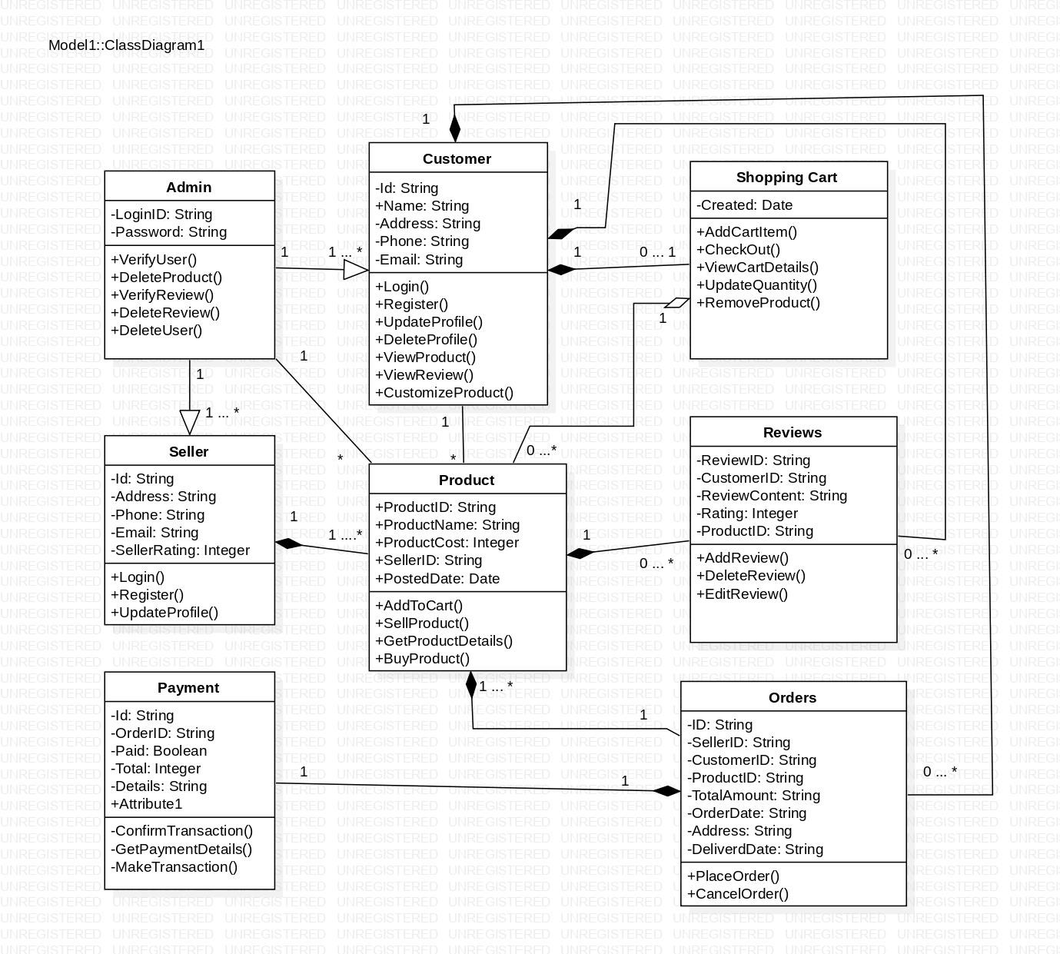

## ACTIVITY DIAGRAM

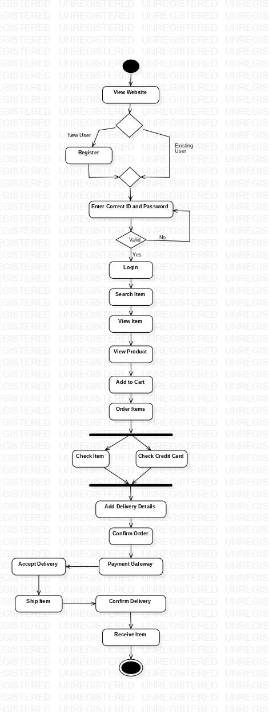

* 1. **SEQUENCE DIAGRAM**

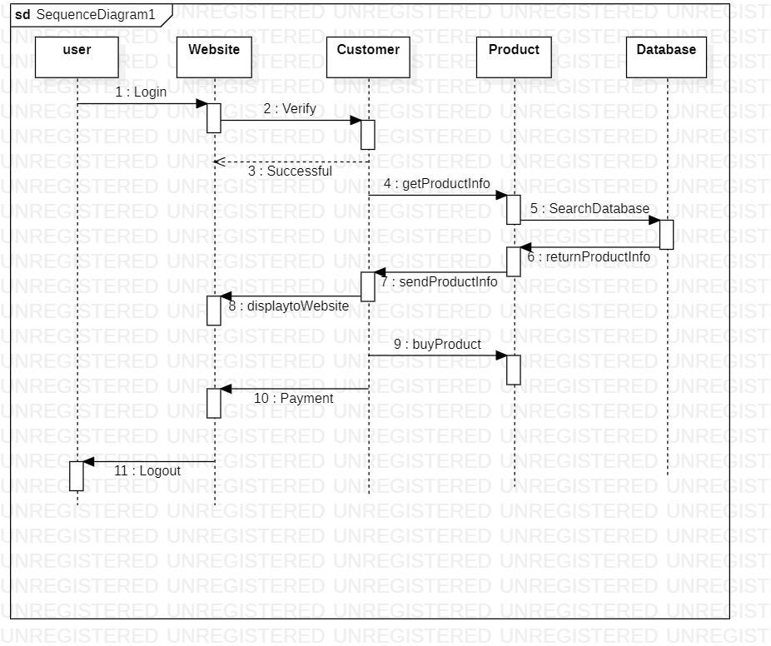

## DEPLOYMENT DIAGRAM

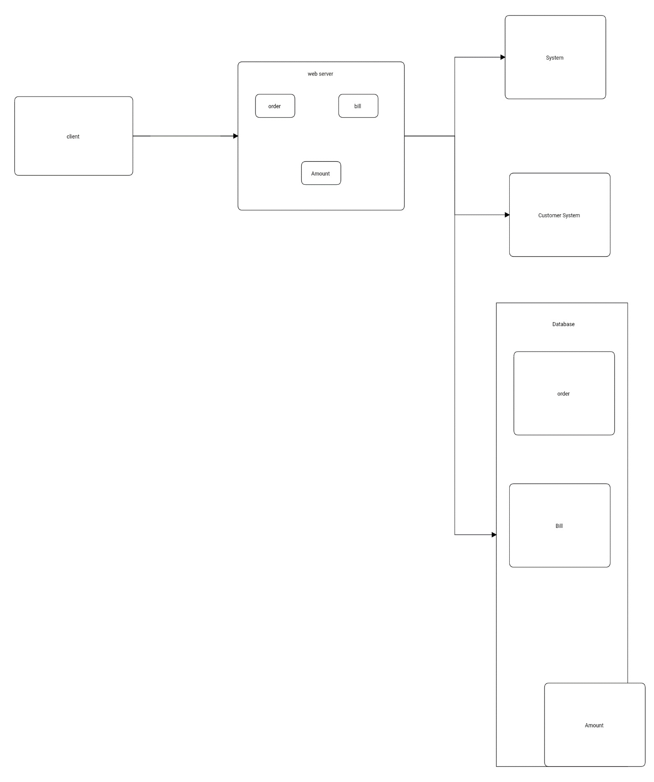

* 1. **MODULE HIERARCHY DIAGRAM**

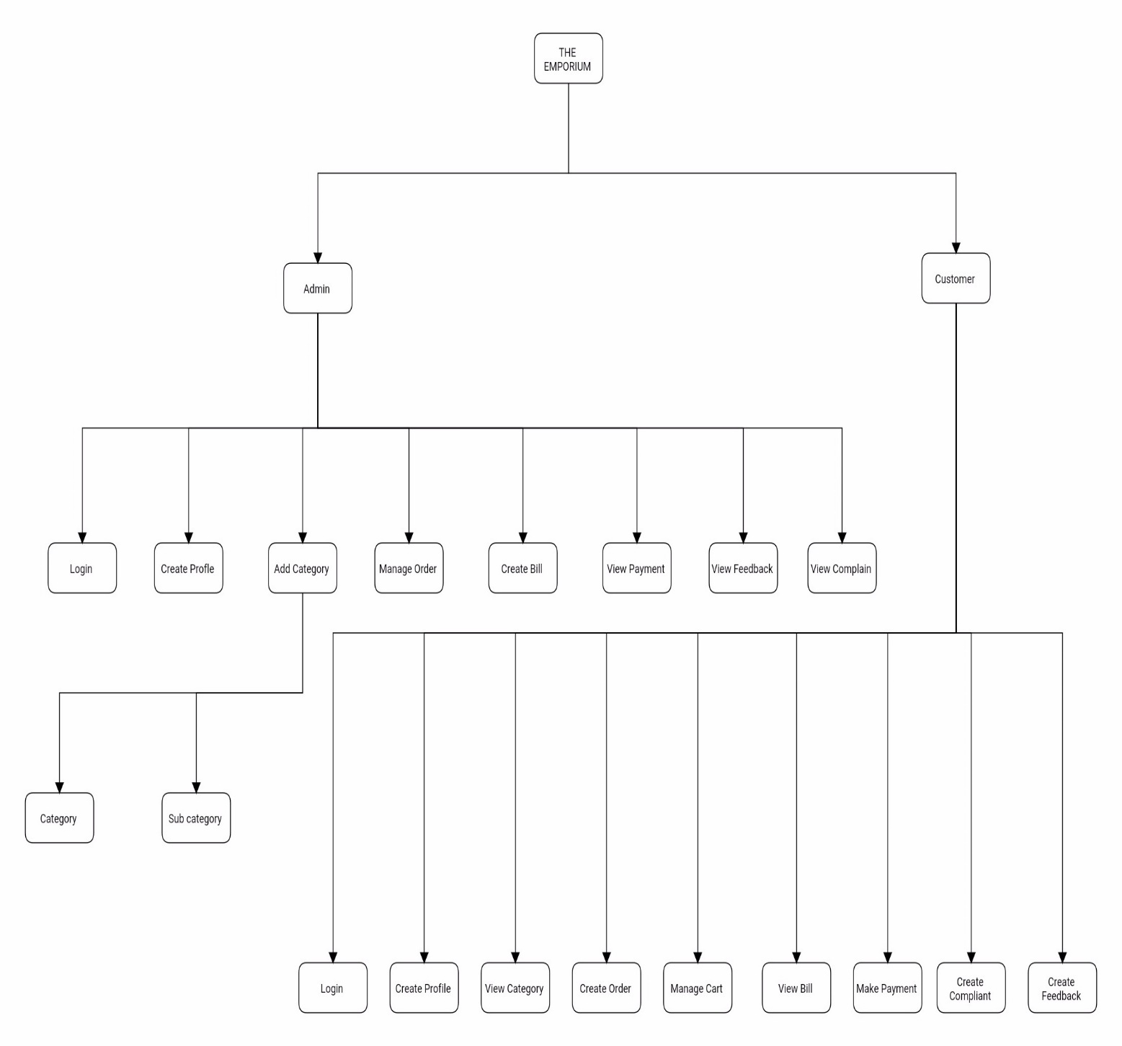

## SAMPLE INPUT AND OUTPUT SCREENS

* **Customer Login :**

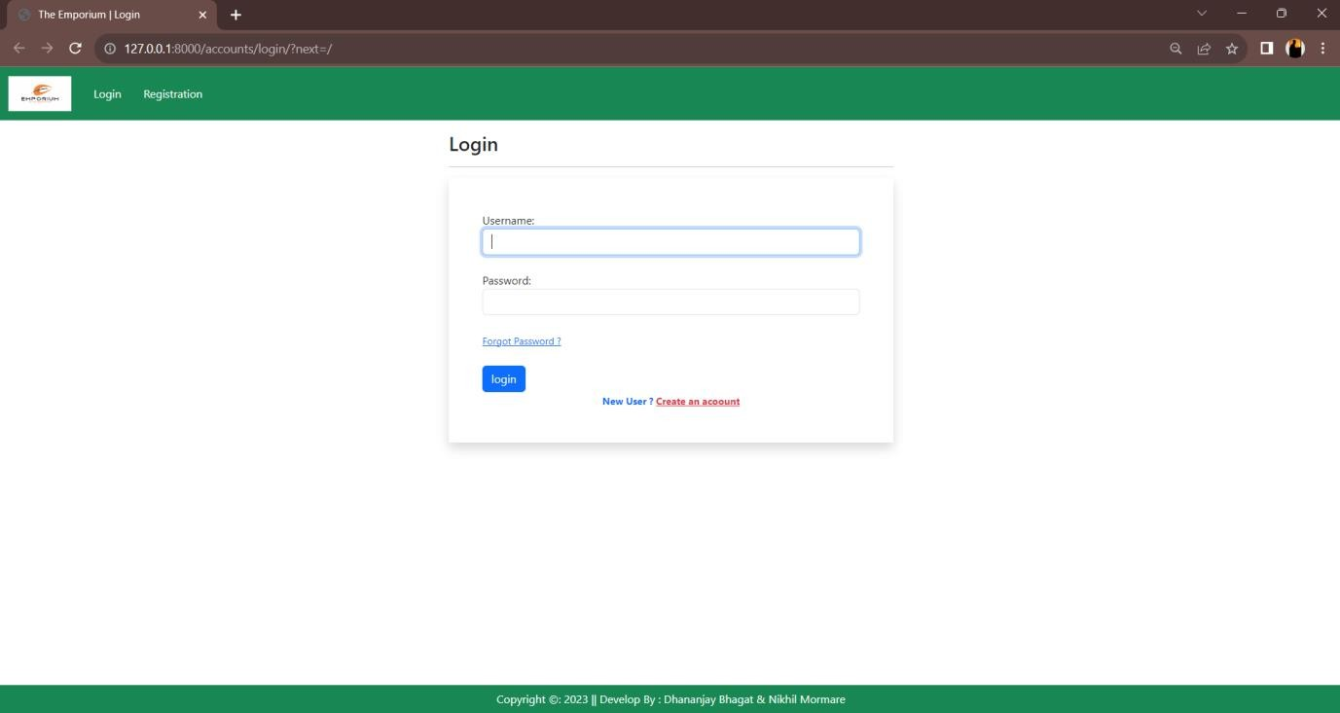

* 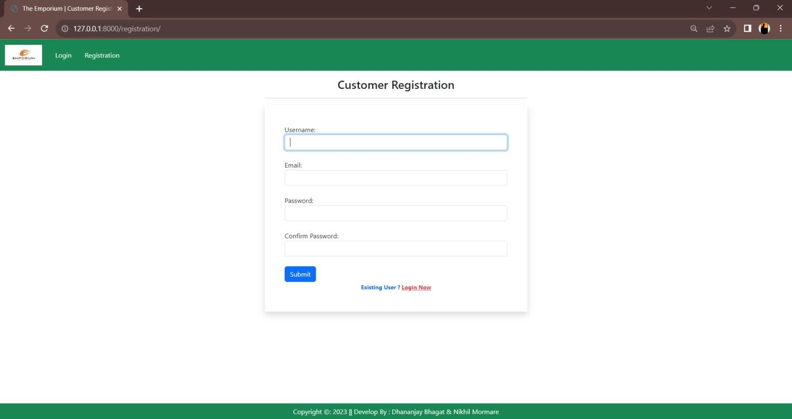**Customer Registration**
* **Dashboard :**

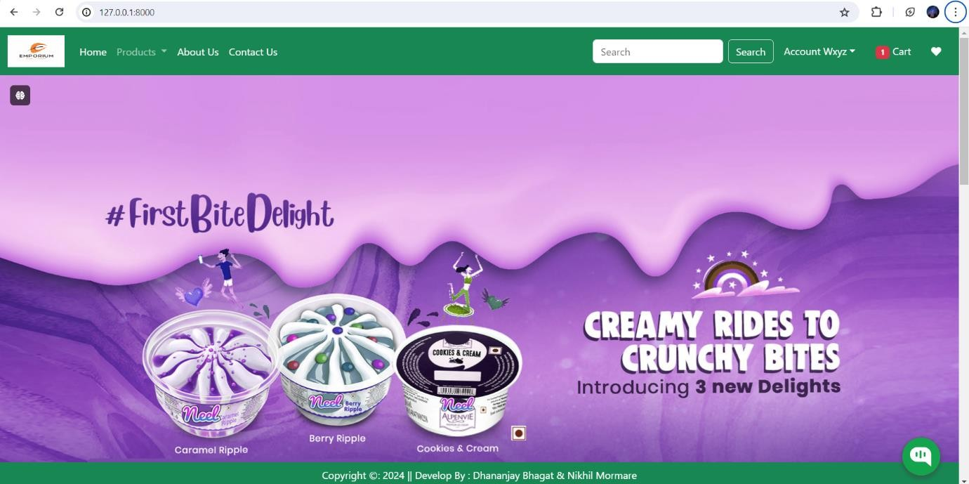

* **Purchase Product :**

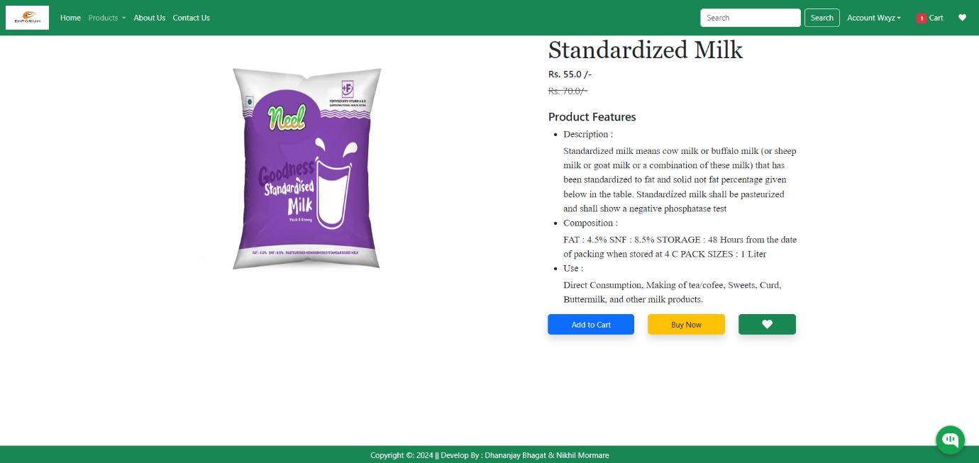

* **Customer Profile**

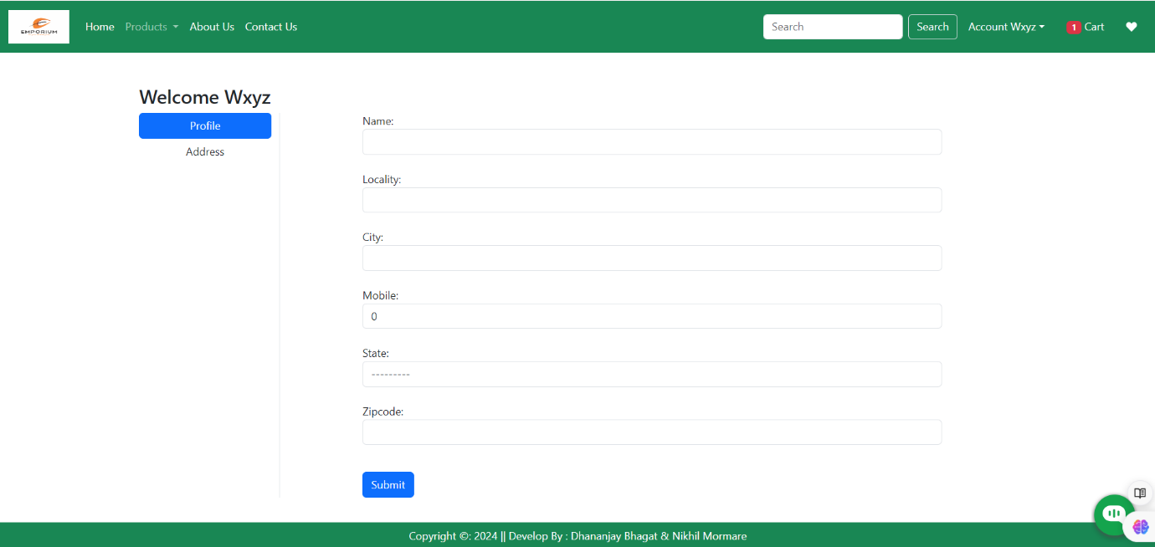

* **Shopping Cart**

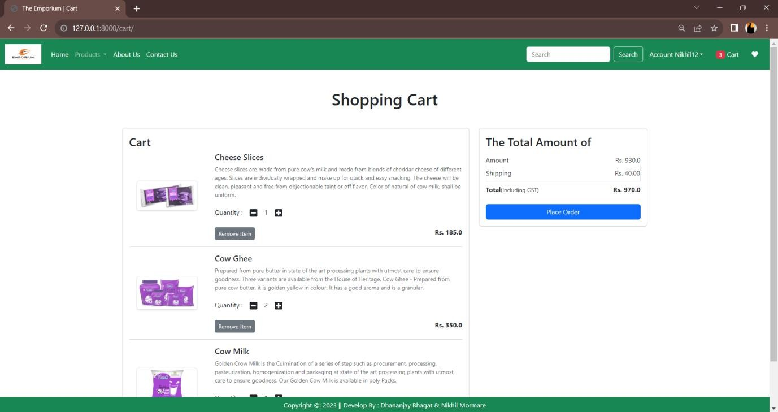

* **Checkout**

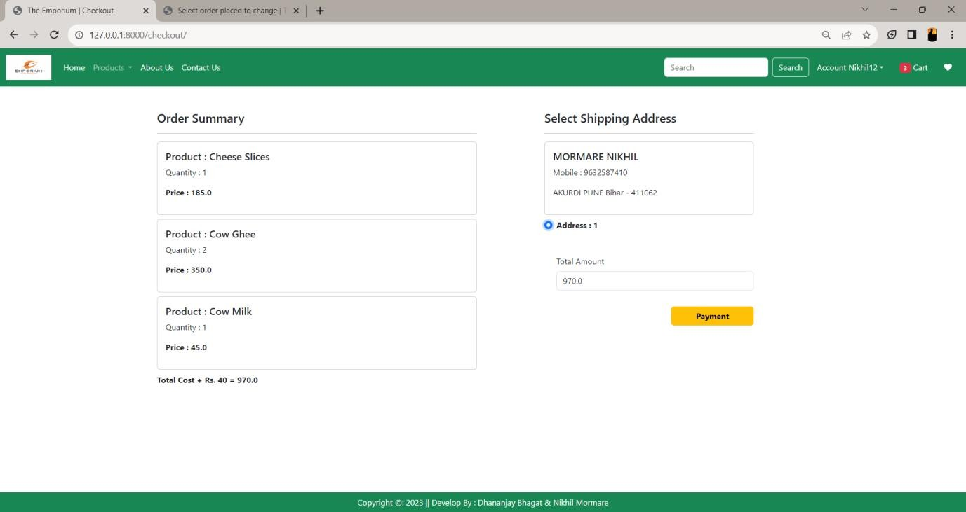

* **Order**

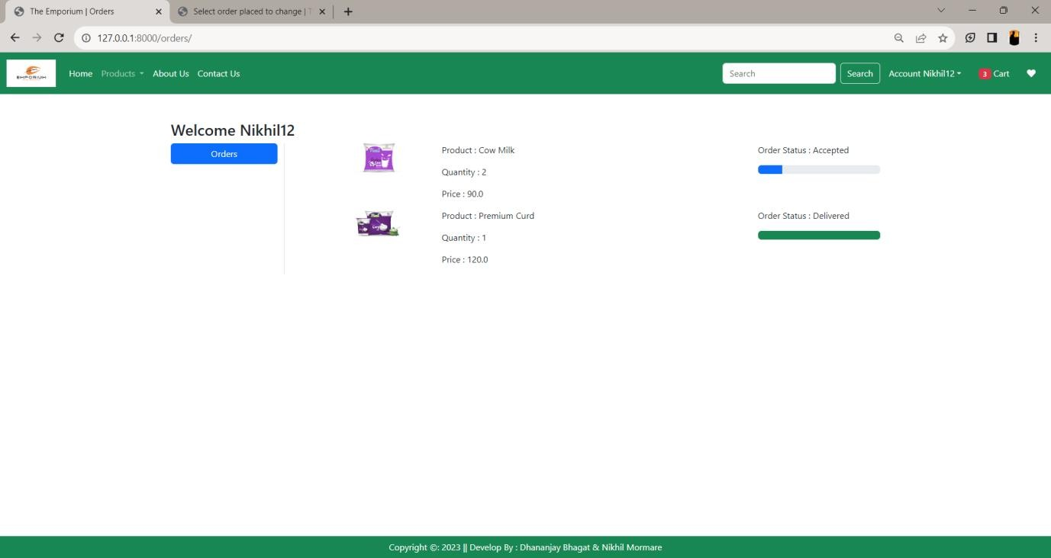

* **Product Category**

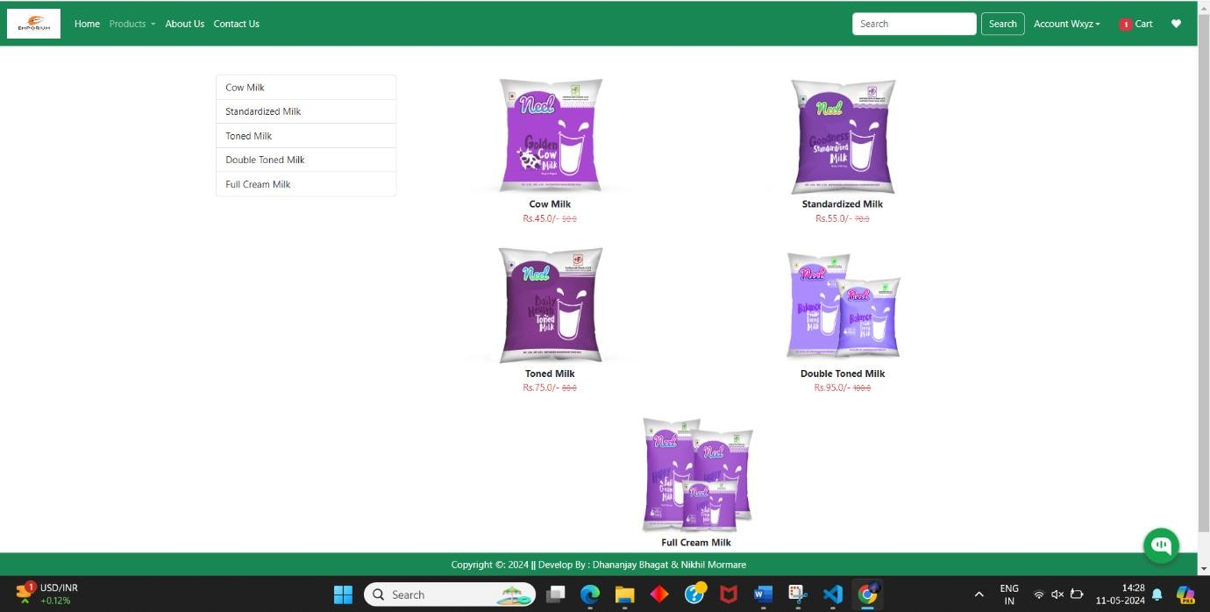

* **Payment**

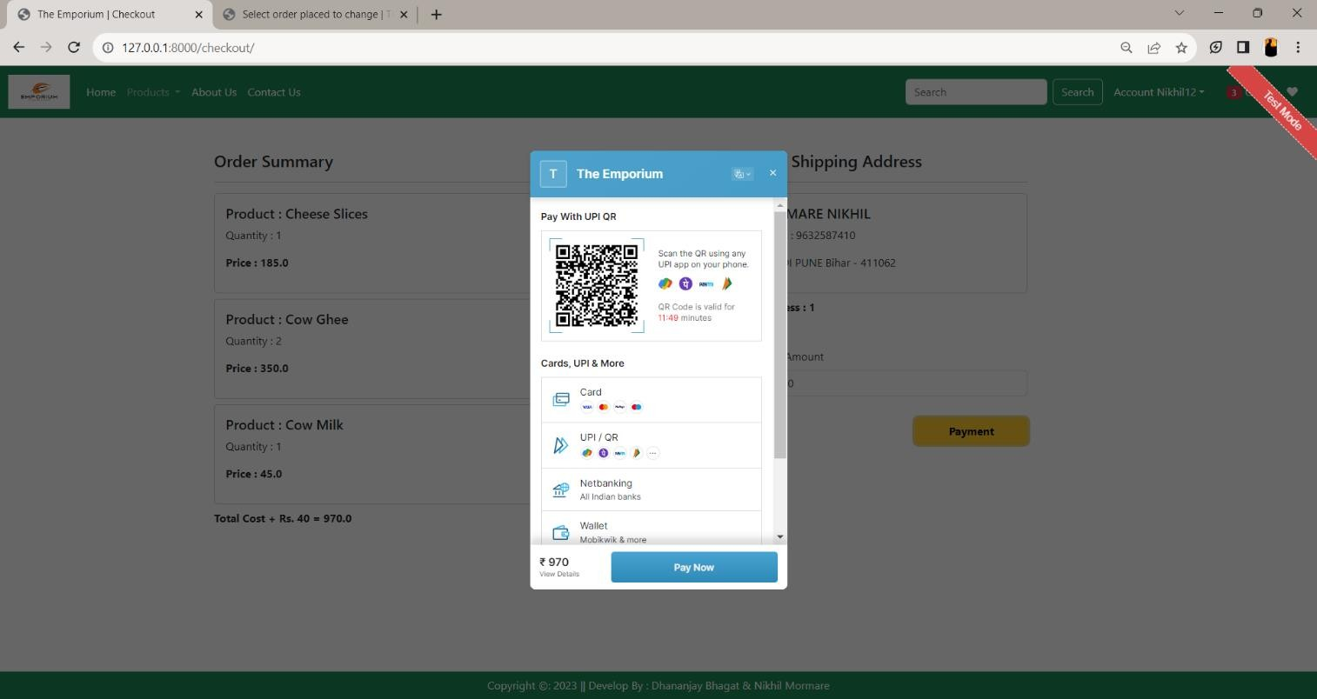

* **Chatbot**

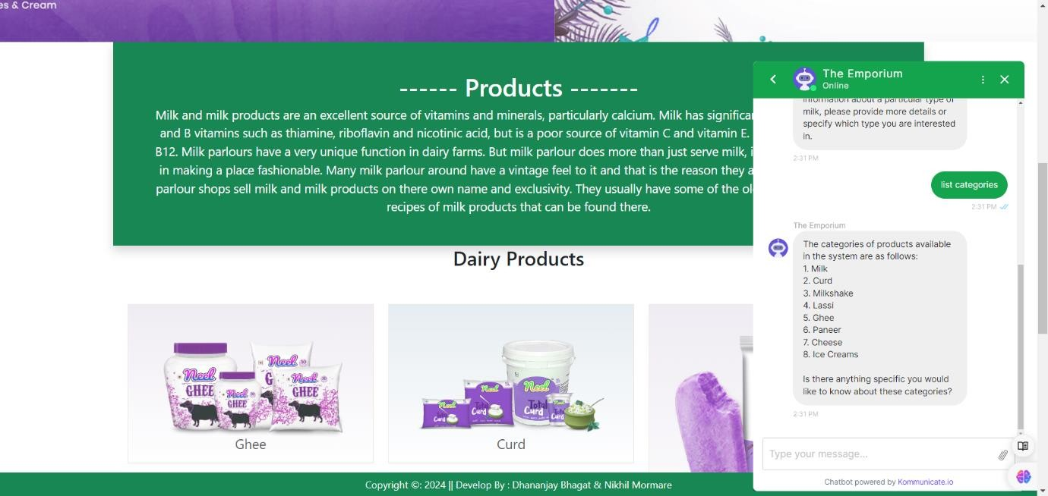

* **About Us**

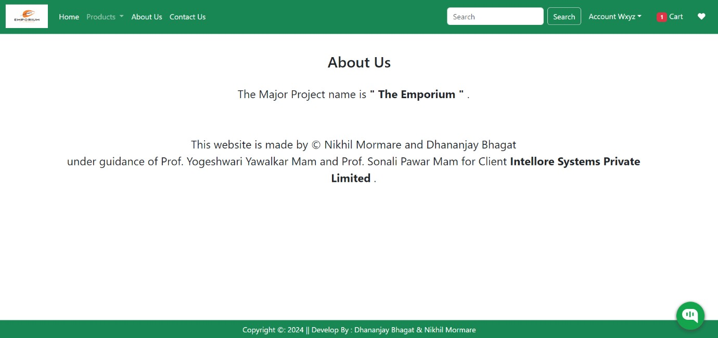

* **Contact Us**

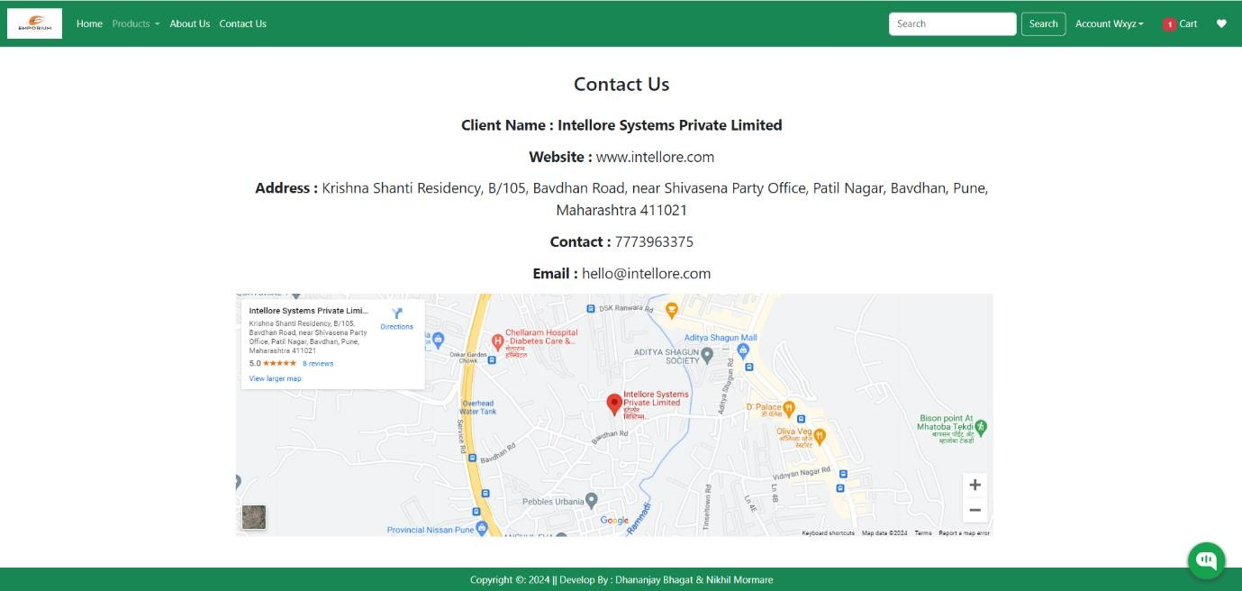

* **Search Product**

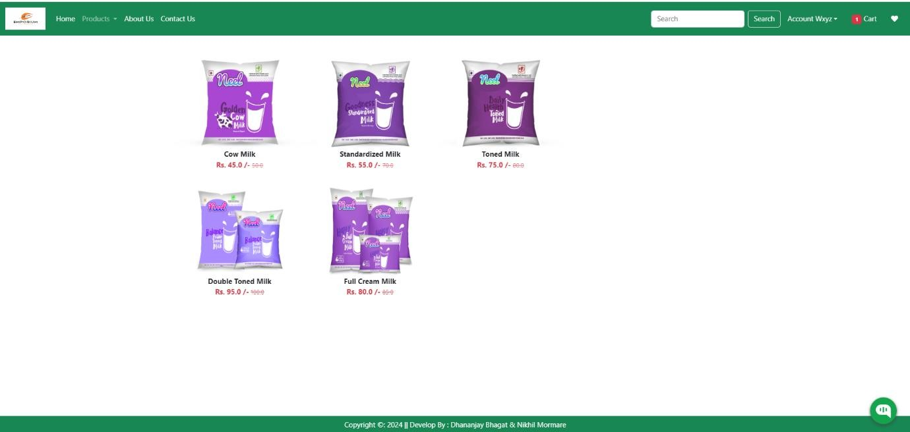

**Chapter No. 4**

**CODING**

## 4.1 CODING SNIPPETS

1. **Coding of Home Page :**

<!DOCTYPE html>

{% load static %}

<html lang="en">

<head>

<meta charset="UTF-8">

<meta name="viewport" content="width=device-width, initial-scale=1.0">

<link href="[https://cdn.jsdelivr.net/npm/bootstrap@5.3.0/dist/css/bootstrap.min.css](https://cdn.jsdelivr.net/npm/bootstrap%405.3.0/dist/css/bootstrap.min.css)" rel="stylesheet"

integrity="sha384- 9ndCyUaIbzAi2FUVXJi0CjmCapSmO7SnpJef0486qhLnuZ2cdeRhO02iuK6FUUV M" crossorigin="anonymous">

<link rel="stylesheet" href="{% static 'app/css/owl.carousel.min.css' %}">

<link rel="stylesheet" href="{% static 'app/css/all.min.css' %}">

<link rel="stylesheet" href="{% static 'app/css/style.css' %}">

<script src="https://checkout.razorpay.com/v1/checkout.js"></script>

<title>The Emporium | {% block title %}{% endblock title %}</title>

</head>

<body>

<nav class="navbar navbar-expand-lg navbar-dark bg-success">

<div class="container-fluid">

<a class="navbar-brand" href="#">

<img src="{% static '\app\images\banner\product\emporiumlogo.png' %}" width="90" height="50"/></a>

<button class="navbar-toggler" type="button" data-bs-toggle="collapse" data-bs- target="#navbarSupportedContent"

aria-controls="navbarSupportedContent" aria-expanded="false" aria- label="Toggle navigation">

<span class="navbar-toggler-icon"></span>

</button>

<div class="collapse navbar-collapse" id="navbarSupportedContent">

<ul class="navbar-nav me-auto mb-2 mb-lg-0">

{% if request.user.is_authenticated %}

<li class="nav-item">

<a class="nav-link active" aria-current="page" href="/">Home</a></li>

<li class="nav-item dropdown">

<a class="nav-link dropdown-toggle" href="#" role="button" data-bs- toggle="dropdown" aria-expanded="false"> Products

</a>

<ul class="dropdown-menu">

<li><a class="dropdown-item" href="{% url 'category' 'ML'

%}">Milk</a></li>

<li><a class="dropdown-item" href="{% url 'category' 'CR'

%}">Curd</a></li>

<li><a class="dropdown-item" href="{% url 'category' 'MS'

%}">Milkshake</a></li>

<li><a class="dropdown-item" href="{% url 'category' 'LS'

%}">Lassi</a></li>

<li><a class="dropdown-item" href="{% url 'category' 'GH'

%}">Ghee</a></li>

<li><a class="dropdown-item" href="{% url 'category' 'PN'

%}">Paneer</a></li>

<li><a class="dropdown-item" href="{% url 'category' 'CZ'

%}">Cheese</a></li>

<li><a class="dropdown-item" href="{% url 'category' 'IC' %}">Ice- Creams</a></li></ul></li>

<li class="nav-item">

<a class="nav-link text-white" href="{% url 'about' %}">About Us</a></li>

<li class="nav-item">

<a class="nav-link text-white" href="{% url 'contact' %}">Contact

Us</a></li></ul><form class="d-flex" role="search" action="/search">

<input class="form-control me-2" type="search" placeholder="Search" name="search" aria-label="Search">

<button class="btn btn-outline-success border text-white" type="submit">Search</button>

</form></div>

<ul class="navbar-nav me-auto mb-2 mb-lg-0">

<li class="nav-item dropdown mx-2">

<a class="nav-link dropdown-toggle text-white" href="#" id="profileDropdown" role="button"

data-bs-toggle="dropdown" aria-expanded="false">Account

{{request.user.username|capfirst}}</a>

<ul class="dropdown-menu" aria-labelledby="profileDropdown">

<li><a class="dropdown-item" href="{% url 'profile'

%}">Profile</a>

</li>

<li><a class="dropdown-item" href="{% url 'orders'%}">Orders</a></li>

<li><a class="dropdown-item" href="{% url 'passwordchange'

%}">Change Password</a>

</li>

<li><a class="dropdown-item" href="{% url 'logout'

%}">Logout</a></li>

</ul></li>

<li class="nav-item mx-2">

<a href="{% url 'showcart' %}" class="nav-link text-white"><span class="badge bg-danger">{% if totalitem > 0 %} {{totalitem}} {% endif %}</span> Cart</a></li>

<li class="nav-item mx-2">

<a href="{% url 'showwishlist' %}" class="nav-link text-white"><span class="badge bg-danger">{% if wishitem > 0 %} {{wishitem}} {% endif %}</span>

<i class="fa fa-heart"></i></a></li>

{% else %}

<li class="nav-item mx-2">

<a href="{% url 'login' %}" class="nav-link text-white">Login</a></li>

<li class="nav-item mx-2">

<a href="{% url 'customerregistration' %}" class="nav-link text- white">Registration</a>

</li>

{% endif %}

</ul></div></nav>

{% block banner_slider %}{% endblock banner_slider %}

{% block information %}{% endblock information %}

{% block main-content %}{% endblock main-content %}

{% block payment-gateway %} {% endblock payment-gateway %}

<footer class="container-fluid bg-success fixed-bottom text-center text-white p-2 mt- 5"> Copyright &copy: 2023 ||

Develop By : Dhananjay Bhagat & Nikhil Mormare

</footer>

<script src="[https://cdn.jsdelivr.net/npm/@popperjs/core@2.11.8/dist/umd/popper.min.js](https://cdn.jsdelivr.net/npm/%40popperjs/core%402.11.8/dist/umd/popper.min.js)"

integrity="sha384-I7E8VVD/ismYTF4hNIPjVp/Zjvgyol6VFvRkX/vR+Vc4jQkC+hVqc2pM8ODewa9r " crossorigin="anonymous"></script>

<script src="[https://cdn.jsdelivr.net/npm/bootstrap@5.3.0/dist/js/bootstrap.min.js](https://cdn.jsdelivr.net/npm/bootstrap%405.3.0/dist/js/bootstrap.min.js)" integrity="sha384-

fbbOQedDUMZZ5KreZpsbe1LCZPVmfTnH7ois6mU1QK+m14rQ1l2bGBq41eYeM

/fS" crossorigin="anonymous"></script>

<script src="https://cdnjs.cloudflare.com/ajax/libs/jquery/3.7.0/jquery.min.js"></script>

<script src="{% static 'app/js/owl.carousel.min.js' %}"></script>

<script src="{% static 'app/js/all.min.js' %}"></script>

<script src="{% static 'app\js\myscript.js' %}"></script>

</body>

</html>

1. **Coding of Login Page :**

{% extends 'app/base.html' %}

{% load static %}

{% block title %}Login{% endblock title %}

{% block main-content %}

<div class="container">

<div class="row my-3">

<div class="col-sm-6 offset-sm-3">

<h3>Login</h3>

<hr>

<form action="" method="post" novalidate class="shadow p-5">

{% csrf_token %}

{% for fm in form %}

{{fm.label_tag}} {{fm}} <small class="text- danger">{{fm.errors|striptags}}</small>

{% endfor %}

<small><a href="{% url 'password_reset' %}">Forgot Password

?</a></small>

<input type="submit" class="btn btn-primary mt-4" value="login">

<div class="text-center text-primary fw-bold">

<small>New User ? <a href="{% url 'customerregistration' %}" class="text-danger">Create an

acoount</a></small>

</div>

{% if form.non_field_errors %}

{% for error in form.non_field_errors %}

<p class="alert alert-danger my-3">{{error}}</p>

{% endfor %}

{% endif %}

</form>

</div>

</div>

</div>

{% endblock main-content %}

1. **Coding of Product Detail Page :**

{% extends 'app/base.html' %}

{% load static %}

{% block title %}Category{% endblock title %}

{% block main-content %}

<div class="container">

<div class="row flex justify-content-between">

<div class="img2 col-lg-5 mt-5">

<img src="{{product.product_images.url}}"

class="image col-xs-6 col-sm-12 col-lg-12 mt-3 text-sm-center w-100 h- 75" alt="">

</div>

<div class="productdetail col-lg-5">

<h1 style="font-family: Georgia; font-size :50px;">{{product.title}}</h1>

<h5> Rs. {{product.discounted_price}} /-</h5>

<small class="text-decoration-line-through text-muted fs-5">

<del>Rs. {{product.selling_price}}/-</del>

</small>

<h4>Product Features</h4>

<ul class="fs-5" style="font-family : Rajdhani;">

<li><h5>Description : </h5>{{product.description}}</li>

<li><h5>Composition : </h5> {{product.composition}}</li>

<li><h5>Use : </h5> {{product.prodapp}}</li>

</ul>

<form action="/add-to-cart" class="d-inline">

<input type="hidden" name="prod_id" value="{{product.id}}"/>

<button type="submit"

class="btn btn-primary shadow px-5 py-2">Add to Cart

</button>

</form>

<a href="{% url 'showcart' %}" class="btn btn-warning shadow px-5 py-2 ms- 4">Buy Now</a>

{% if wishlist %}

<a pid={{product.id}} class="minus-wishlist btn btn-danger shadow px-5 py- 2 ms-4"><i

class="fas fa-heart fa-lg"></i></a>

{% else %}

<a pid={{product.id}} class="plus-wishlist btn btn-success shadow px-5 py-2 ms-4"><i class="fas fa-heart fa-lg"></i></a>

{% endif %}

</div>

</div>

</div>

{% endblock main-content %}

**Chapter No. 5**

**TESTING**

## TEST STRATEGY

**Unit Testing:**

Unit testing involves the examination of individual units or components of a software application in isolation from the rest of the system. Its purpose is to ensure that each unit functions correctly according to its specifications.

Typically conducted by developers during the coding phase, unit tests validate the behavior of small units of code, such as functions or methods, and detect any defects early in the development process.

## Integration Testing:

Integration testing focuses on testing the interactions between different units or components of the software. It ensures that these units work together seamlessly and that data flows correctly between them.

Integration testing is carried out after unit testing and before system testing, aiming to identify any issues that may arise due to the integration of various components.

## System Testing:

System testing evaluates the behavior of the complete and fully integrated software product as a whole. It verifies that the entire system meets specified requirements and functions correctly in its intended environment.

System testing encompasses various aspects such as functionality, usability, performance, security, and reliability, testing the system from end to end to ensure its readiness for deployment.

* Whether all the forms are properly working or not
* Whether all the forms are properly linked or not
* Whether all the images properly displayed or not.
* Whether data retrieval is proper or not.

## Test Cases

Test cases are built around specifications and requirements, i.e., what the application is supposed to do. Test cases are generally derived from external descriptions of the software, including specifications, requirements and design parameters.

Although the tests used are primarily functional in nature, non-functional tests may also be used. The test designer selects both valid and invalid inputs and determines the correct output without any knowledge of the test object's internal structure.

## Test Design Techniques

Typical black-box test design techniques include:

* Decision table testing
* All-pairs testing
* State transition Analysis
* Equivalence partitioning
* Boundary value analysis
* Cause-effect graph
* Error guessing

## TEST CASES

|  |  |  |  |  |  |  |
| --- | --- | --- | --- | --- | --- | --- |
| **Test Case Identifier** | **Purpose** | **Preconditions** | **Test Steps** | **Expected Result** | **Actual Result** | **Pass/Fail** |
| TC1 | User Registration | User is on the registration page. | 1. Navigate to the registration page.2. Enter valid user details.3. Click on the "Register" button. | User is registered successfully. | User is registered successfully. | Pass |
| TC2 | User Login | User is on the login page. | 1. Navigate to the login page.2. Enter valid credentials.3. Click on the "Login" button. | User is logged in successfully. | User is logged in successfully. | Pass |
| TC3 | Product Search | User is on the home page. | 1. Navigate to the home page.2. Enter a keyword in the search bar.3. Click on the search button. | Relevant products are displayed. | Relevant products are displayed. | Pass |
| TC4 | Add Product to Cart | User is on the product details page. | 1. Navigate to the product details page.2. Click on the "Add to Cart" button. | Product is added to the cart. | Product is added to the cart. | Pass |
| TC5 | Checkout Process | User has items in the shopping cart. | 1. Navigate to the shopping cart page.2. Click on the "Proceed to Checkout" button.3. Enter shipping and billing information.4. Click on the "Place Order" button. | Order is placed successfully. | Order is placed successfully. | Pass |
| TC6 | User Profile Management | User is on the user profile page. | 1. Navigate to the user profile page.2. Click on the "Edit Profile" button.3. Update user details. | User details are updated successfully. | User details are updated successfully. | Pass |

|  |  |  |  |  |  |  |
| --- | --- | --- | --- | --- | --- | --- |
| **Test Case Identifier** | **Purpose** | **Preconditions** | **Test Steps** | **Expected Result** | **Actual Result** | **Pass/Fail** |
| TC8 | View Product Details | User is on the product details page. | Navigate to the product details page. | Product details page is displayed. | Product details page is displayed. | Pass |
| TC9 | Update Shopping Cart Quantity | User is on the shopping cart page. | Navigate to the shopping cart page.Update the quantity of a product in the cart. | Product quantity is updated successfully. | Product quantity is updated successfully. | Pass |
| TC10 | Remove Product from Cart | User is on the shopping cart page. | Navigate to the shopping cart page.Remove a product from the cart. | Product is removed from the cart successfully. | Product is removed from the cart successfully. | Pass |
| TC11 | Apply Coupon Code | User is on the checkout page. | Navigate to the checkout page.Enter a valid coupon code. | Coupon code is applied successfully. | Coupon code is applied successfully. | Pass |
| TC12 | Verify Order Confirmation | An order has been placed successfully. | Place an order.Navigate to the order confirmation page. | Order confirmation page is displayed. | Order confirmation page is displayed. | Pass |
| TC13 | Track Order Status | An order has been placed successfully. | Navigate to the order tracking page. | Order tracking page is displayed. | Order tracking page is displayed. | Pass |

|  |  |  |  |  |  |  |
| --- | --- | --- | --- | --- | --- | --- |
| **Test Case Identifier** | **Purpose** | **Preconditions** | **Test Steps** | **Expected Result** | **Actual Result** | **Pass/Fail** |
| TC14 | User Interface | User is accessing the system interface. | 1. Navigate to the system interface.2. Verify that the interface is user-friendly. | The interface is easy to use and navigate, enhancing user experience. | The interface is easy to use and navigate. | Pass |
| TC15 | Admin Login | Admin login page is accessible. | 1. Navigate to the admin login page.2. Enter valid admin credentials.3. Click on the "Login" button. | Admin is logged in securely. | Admin is logged in securely. | Pass |
| TC16 | Product Inventory Management | Admin is logged in. | 1. Navigate to the product management module.2. Add a new product to the inventory.3. Update product details.4. Verify product information accuracy. | Product inventory is efficiently managed with accurate information. | Product inventory is efficiently managed with accurate information. | Pass |
| TC17 | Customer Records | Admin is logged in. | 1. Navigate to the customer module.2. Add a new customer record.3. Update customer details.4. Verify customer information accuracy. | Customer records are stored and organized correctly. | Customer records are stored and organized correctly. | Pass |
| TC18 | Search Functionality | User is on the system interface. | 1. Use the search module to look for a specific product.2. Verify search results. | Search module enables quick access to specific products or information. | Search module enables quick access to specific products or information. | Pass |
| TC19 | Purchase Transaction | User is logged in. | 1. Add products to the cart.2. Proceed to checkout.3. Complete the purchase transaction. | Purchase transaction is completed successfully, and products are added to the inventory. | Purchase transaction is completed successfully, and products are added to the inventory. | Pass |

**Chapter No. 6**

**LIMITATIONS OF PROPOSED SYSTEMS**

**LIMITATIONS OF THE PROPOSED SYSTEM**

Limitations of the Proposed System:

## Digital Divide:

Not all customers may have access to the internet or be comfortable using online platforms. This limitation can impact the reach of the Online Shopping system, especially in areas with limited internet connectivity or among older demographics who may be less tech-savvy. It is essential for the plafforn to consider alternative options for customers who prefer in-person shopping or do not have acess to the online platform.

## Technical Issues:

Online systems are susceptible to technical glitches, server downtime, or internet connectivity problems. These issues can disrupt the shopping experience and lead to frustration among customers. To mitigate this limitation, the platform must invest in robust server infrastructure, conduct regular maintenance, and provide efficient customer support to address any technical issues promptly.

## Data Security Concerns:

Storing customer data and sensitive payment information online requires stringent security measures. Any data breaches or cyber-attacks could lead to compromising customer information, eroding trust in the platform. To overcome this limitation, the system must implement encryption, secure payment gateways, and adhere to industry standards for data protection. Regular security audits and proactive measures can instill confidence in customers regarding their data security.

## Regulatory Compliance:

Adhering to various e-commerce regulations, tax laws, and data protection requirements can be complex and time-consuming. The system should ensure that it complies with all relevant laws and regulations to avoid legal issues and reputational damage.

## COMBINING WITH THE SCOPE

The Emporium Dairy Management System aims to offer a user-friendly interface for effectively managing dairy products, sales, and customer information. Through intuitive features, it will enable seamless creation and maintenance of customer accounts, facilitating easy updates of contact details and efficient tracking of order statuses.

One of its primary objectives is to provide shop owners with a comprehensive view of sales history, transcending the constraints of traditional paper-based processes.

This visibility empowers them to analyze sales performance over time, facilitating informed decision-making and strategic planning.

The platform aims to mitigate potential challenges arising from the digital divide, technical issues, and data security concerns. To bridge the digital gap, it will provide alternatives for customers without internet access while investing in robust technical infrastructure to ensure smooth operations.

Additionally, stringent security measures will be implemented to safeguard sensitive data and foster customer trust. Furthermore, the system will address issues related to return and refund handling, ensuring a streamlined process for both customers and shop owners.

It will also focus on accurate product representation, market competition, delivery logistics, and customer trust to enhance the overall shopping experience.

**Chapter No. 7**

**PROPOSED ENHANCEMENT**

## PROPOSED ENHANCEMENT

Current system is developed according to current requirements which can be added later. In this, the system can be merged with another system to make a bigger system invoking many functions on it, fostering interoperability and expansion possibilities for future integration with complementary systems.

No project is ever complete in itself; there are always minor or major changes in the project according to user requirements, emphasizing the iterative nature of software development and the importance of ongoing adaptation to meet evolving needs.

This project could be enhanced in the sense that it can overcome its limitations in the future, serving as a springboard for continuous improvement and innovation to address emerging challenges and seize new opportunities.

Latest electronic and software technologies can help to bring in more enhancements which would help to make the system more user-friendly and also help to maintain adequate security, leveraging advancements in technology to enhance usability, performance, and security posture, ensuring that the system remains robust and resilient against potential threats.

To make the application as online so that it would be helpful to everyone, extending accessibility and convenience by transitioning the application to an online platform, enabling broader reach and facilitating seamless access for users across different locations and devices.

**Chapter No. 8**

**CONCLUSION**

## CONCLUSION

We have tried to develop a system that can be a great help to the modern technological world to register the requirements and needs from the user, ensuring seamless integration into existing workflows.

We have left all the options open so that if there is any other future requirement in the system by the user for enhancement of the system, then it is possible to implement them, fostering adaptability and scalability for evolving needs.

The “THE EMPORIUM” initiates the objective of providing an organizer with customized and powerful operating operations and management system side, equipped with all the options like adding customers, vendors, products, shops, along with features for updating them whenever necessary, ensuring comprehensive functionality to meet diverse business demands.

The interface provided is user-friendly and flexible, designed to streamline user interactions and accommodate varying levels of expertise, fostering efficiency and ease of use.

We hope that the project will serve its purpose for which it is developed, by underlining the success of the project, marking a significant milestone in addressing the organizational and operational needs of modern businesses.

**Chapter No. 9**

**BIBLIOGRAPHY**

## BIBLIOGRAPHY

* **Website Reference**
  + [https://www.w3schools.com](https://www.w3schools.com/)

•

<https://docs.djangoproject.com/>

•

<https://realpython.com/>

* + <https://www.wikipedia.org/>
  + [www.geeksforgeeks.org](http://www.geeksforgeeks.org/)

## Books Reference

* + "Django for Beginners" by William S. Vincent
  + "Two Scoops of Django 3.x" by Daniel Roy Greenfeld and Audrey Roy Greenfeld
  + HTML Black Book

**Chapter No. 10**

**USER MANUAL**

## USER MANUAL : ADMIN SIDE

**1. Registration and Login**

i. **Registration**: To access The Emporium Dairy Management System, administrators must create an account. Click on the "Registration" option and provide essential details like your full name, a valid email address, and a secure password. Ensure the password is strong to protect your account.

ii. **Login**: Once registered, use the "Login" option to enter your credentials and access the admin panel. Enter your registered email address and password. If issues arise, verify the information entered or use the "Forgot Password" option to reset.

**2**. **My Dashboard**

i. **Overview**: Upon successful login, administrators are directed to the admin dashboard. Here, a comprehensive overview of crucial platform data is provided. Metrics may include the total number of registered customers, active delivery boys, total products available, and recent user feedback. Visual representations like charts or graphs may also be displayed.

ii. **Navigation**: The dashboard features a navigation menu for accessing different sections and functionalities within the admin panel. Options include customer management, product management, delivery boy management, and view sections.

**3. Profile Management**

i. **Accessing Profile**: Click on the "Profile" option in the navigation menu to view your admin profile. Here, personal information such as your full name, email address, and other registration details are displayed.

ii**. Editing Profile**: To update profile information, click on the "Edit" option next to the respective field. Modify details like your name, email address, and password as necessary. Remember to save any changes made to your profile.

About The Emporium Dairy Management System:

The Emporium Dairy Management System is a comprehensive platform designed to streamline the management of dairy products, sales, and customer interactions. With a user-friendly interface, it facilitates tasks such as inventory management, order processing, and customer relationship management. The system empowers dairy farm owners and processing facilities to optimize operations, enhance productivity, and drive business growth.

**Key Features**:

- Efficient management of dairy product inventory, sales, and customer information.

- User-friendly interface for easy navigation and seamless operation.

- Comprehensive dashboard providing real-time insights into key performance metrics.

- Intuitive tools for product management, order processing, and customer relationship management.

- Robust security measures to safeguard sensitive data and ensure user privacy.

- Customizable features to adapt to the unique needs of dairy farms and processing facilities.

- Ongoing support and updates to ensure the system remains current and effective in meeting user requirements.

With The Emporium Dairy Management System, dairy businesses can streamline operations, enhance efficiency, and drive growth in today's competitive market landscape.

i**. Customer Management:**

In this section, you can efficiently manage customer accounts within "The Emporium" Dairy Management System. As an administrator, you have the authority to add new customers to the platform, edit existing customer information (such as name, email, contact number), and remove customers if necessary. This section also provides insights into customer details and their order history, enabling you to better understand customer behavior and preferences, thus facilitating personalized customer support and marketing strategies.

ii**. Delivery Personnel Management**:

This option grants you control over the delivery personnel operating within "The Emporium" Dairy Management System. You can seamlessly add new delivery personnel, assign orders to them, and monitor their performance. Additionally, you have the capability to edit delivery personnel details and remove them from the platform if necessary. This feature ensures efficient order delivery management and enhances customer satisfaction through timely and reliable delivery services.

iii. **Product Management**:

As an administrator, you hold the responsibility of managing the diverse range of dairy products available on "The Emporium" platform. This section empowers you to add new products, update product details (such as name, description, price, and availability), and remove products that are no longer offered. By efficiently managing the product inventory, you ensure that customers have access to a comprehensive range of dairy products, enhancing their shopping experience.

iv**. Product Category Management**:

This section allows you to streamline the organization of products within "The Emporium" Dairy Management System by creating, editing, or deleting product categories. Organizing products into distinct categories facilitates seamless navigation for customers, enabling them to easily find the dairy products they desire. By effectively managing product categories, you enhance the platform's usability and ensure a user-friendly shopping experience for customers.

**5**. **View**

i. **Customer View**:

Utilize this section to search for specific customers based on various criteria such as name, email, or order history within "The Emporium" Dairy Management System. Viewing customer details enables you to gain insights into their preferences, purchase history, and interactions with the platform, facilitating personalized customer support and targeted marketing efforts.

ii**. Product View**:

The product view section provides you with the ability to efficiently search for dairy products based on their names, categories, or availability status within "The Emporium" Dairy Management System. This feature streamlines the process of managing product details, enabling you to quickly locate products and make necessary updates to their information, ensuring accurate and up-to-date product listings.

iii**. Category View**:

In this section, you can conveniently browse through all available product categories within "The Emporium" Dairy Management System. By organizing products into distinct categories, you enhance the platform's usability and ensure a seamless shopping experience for customers. This feature simplifies the process of managing product categories, allowing you to efficiently organize and update category information as needed.

**USER MANUAL : CUSTOMER SIDE**

1. **Website**:

i. Accessing Website: To access "The Emporium" website, open your web browser and enter the platform's URL.

ii. Main Page: Upon accessing the website, customers will land on the main page, presenting essential options such as registration, login, feedback, about us, and contact us. From here, customers can register or log in to their accounts, explore information about "The Emporium," and provide feedback.

**2**. **Registration and Login:**

i. **Registration**: To place orders and access personalized features, customers need to register on the platform. Click on the "Registration" option and provide required details like full name, email address, and a secure password. Creating an account allows customers to save their preferences, track orders, and receive personalized offers.

ii. **Login**: If you already have an account, use the "Login" option to enter your registered email address and password. Logging in gives you access to your account and all its features. In case you forget your password, use the "Forgot Password" option to reset it.

**3. My Account**:

i. **Accessing My Account**: After logging in, you will be directed to your account page. This page contains various details about your account and activities on the platform.

ii. **Viewing Account Details**: Your account details may include your full name, email address, contact number, and delivery address. You can view your order history to track your purchases and deliveries.

**4. Shopping Page**:

i**. Exploring Products**: The shopping page allows customers to explore available dairy products on "The Emporium" platform. Customers can browse through different product categories or use the search feature to find specific items.

ii. **Product Details**: Click on a product to view its detailed description, images, pricing, and availability status. Understanding product details helps customers make informed purchasing decisions.

**5. Account Settings**

i**. Accessing Account Settings**: To manage your account details, navigate to the "Account Settings" section in the menu bar.

ii. **Updating Account Information**: In the account settings section, you can update personal information such as your full name, email address, and contact number. Ensure to save any changes made to your account details for future reference.

**6. Address Settings**

i. **Managing Shipping Addresses**: Within this section, customers can efficiently manage their shipping addresses. Users have the option to add new addresses, edit existing ones, or remove outdated addresses to ensure smooth delivery of orders.

**7**. **Payment Method**

i**. Selecting Payment Options**: During the checkout process, customers can choose their preferred payment method. Available options may include credit/debit cards, PayPal, or other supported payment gateways.

ii**. Entering Payment Details**: Depending on the selected payment method, customers need to securely enter the relevant payment details to complete the transaction.

**8**. **Preferences**

**i. Customizing Experience**: Some platforms offer preference settings that allow customers to customize their experience. Preferences might include language selection, theme customization, and notification settings. Explore the preference options to tailor the platform to your preferences.

**Incorporating Project Information:**

**5. Account Settings**

**i. Accessing Account Settings**: To manage your account details in "The Emporium" Dairy Management System, simply click on the "Account" option located in the top-right corner of the dashboard.

**ii. Updating Account Information**: Within the account settings section, users can effortlessly update personal details such as their full name, email address, and contact number. Any modifications made should be saved by clicking the "Save Changes" button for future reference.

**6. Address Settings**

**i. Managing Shipping Addresses**: In this section of "The Emporium," customers can conveniently manage their shipping addresses. Users have the flexibility to add new addresses, edit existing ones, or remove outdated addresses to ensure the smooth delivery of dairy products.

**7. Payment Method**

**i. Selecting Payment Options**: During the checkout process on "The Emporium" platform, customers are presented with various payment methods to choose from, including credit/debit cards, PayPal, or other supported gateways.

**ii. Entering Payment Details**: Depending on the preferred payment method selected, users are prompted to securely enter relevant payment details to facilitate the completion of the transaction seamlessly.

**8. Preferences**

**i. Customizing Experience**: "The Emporium" understands the importance of a personalized shopping experience. Therefore, users have the option to customize their preferences, such as language selection, theme customization, and notification settings, to enhance their overall experience on the platform.